**A SHORT-TERM INTERNSHIP REPORT**

**On**

**MERN FULL STACK DEVELOPMENT**

Submitted to Department of Computer Science

# By

## ABHISARIKA GUDLA

III BSC

**Under the Esteemed Guidance of**

**D. Ravi Sankar MCA**

## LECTURER

**Department of Computer Science**

e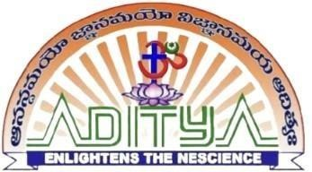

**KAKINADA SRI ADITYA DEGREE COLLEGE**

**SRIKAKULAM**

**KAKINADA SRI ADITYA DEGREE COLLEGE**

**Department of Computer science**



## CERTIFICATE

This is to certify that The Short-Term Internship entitled, “**Mern Full Stack** **Development**” is a bonified work of **ABHISARIKA GUDLA**, bearing **23221000957013**, **III BSC,** submitted to the Department of Computer Science, Kakinada Sri AdityaDegree College, Srikakulam for the academic year 2024-2025.

**Internship Guide**

**Sri Sai Kumar Parla**

**Head of the Department**

**Sri D. Ravi Sankar**

**External Examiner Principal**

**KAKINADA SRI ADITYA DEGREE COLLEGE**

**Department of Computer Science**



### DECLARATION BY THE STUDENT

I hereby declare that the work described in this Short-Term Internship, entitled “**Mern Full Stack Development”** which is being submitted by me in partial fulfilment of the requirements for the award of degree of **Bachelor of Computer Science** (B.Sc) from the Department of Computer Science to Kakinada Sri Aditya Degree College, Srikakulam under the guidance of **Mr. Sai Kumar Parla, Adhoc Network Tech Company, India and Canada.**

**Place: Srikakulam**

**Date: 26-july-2025**

### KAKINADA SRI ADITYA DEGREE COLLEGE

**Department of Computer Science**



**CERTIFICATE FROM THE SUPERVISOR**

This is to certify that the Short- Term Internship entitled,” **Mern Full Stack Development”,** that is being submitted by **ABISARIKA GUDLA** bearing **23221000957013, III BSc,** which is being submitted by me in partial fulfilment of the requirements for the award of degree of **Bachelor of Science** from the Bachelor of Computer science to Kakinada Sri Aditya Degree College, bonified work carried out by him under my guidance and Supervision.

**Mr. D. Ravi Sankar MCA**

### ACKNOWLEDGEMENT

No endeavour is completed without the valuable support of others. I would like to take this opportunity to extend my sincere gratitude to all those who have contributed to the successful completion of this Short-Term Internship Project Report.

It is privilege to thank **Dr. N. SESHA REDDY, Chairman Sir**, Aditya group of institutions for providing state-of-the Art facilities, experienced and talented faculty members.

It is privilege to thank **Dr. N. SUGUNA REDDY, Secretary Madam**, Aditya group of institutions for providing Short-Term Internship Project Report from Adhoc.

I thank **Dr. B. E. V. L. NAIDU Sir,** Academic Director, Aditya Degree College for his continuous support and encouragement in my endeavour.

At this juncture I feel deeply honoured in expressing my sincere thanks to **DANIEL BENJAMIN** Sir, Chartered **Engineer**, AMIE, B.Tech, Project Director, **CEO Devika Pakruthi Mam** of Adhoc Network Tech Company, India and Canada for making the resources available at right time and providing valuable insights leading to the successful completion of my Short-Term Internship Project Report.

We extend our heartfelt thanks to **Mr. Sai Kumar Parla,** our Technical Trainer, for his **exceptional contribution** throughout this internship. His dedication, innovative approach, and ability to make sessions both **interactive and insightful** have truly enhanced the learning experience for all our students. We sincerely appreciate his **strong technical expertise**, **clarity in teaching**, and his unwavering commitment to ensuring that each student gained the best possible understanding.

I express my deep sense of gratitude to **Mr. N.V. VENU GOPAL, Principal**, Kakinada Sri Aditya Degree College-Srikakulam for his Efforts and for giving us permission for carrying out this Short-Term Internship.

I thank **Mr. D. RAVI SANKAR**, Head of the Department of Bachelor of Computer Science, Kakinada Sri Aditya Degree College-Srikakulam, for supporting and encouraging me in completion of my Short-Term Internship.

Finally, I thank all the faculty members of our department who contributed their valuable suggestions in completion of Short-Term Internship report and I also put my sincere thanks to My Parents who stood with me during the whole Short-term Internship.

- **G.Abhisarika**

## ABOUT ADITYA DEGREE COLLEGES

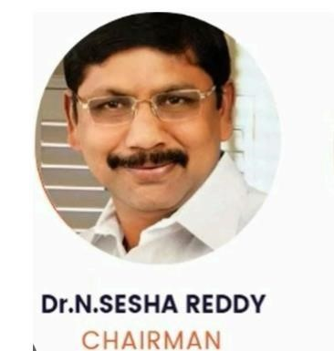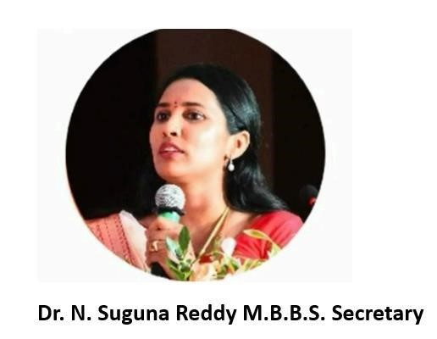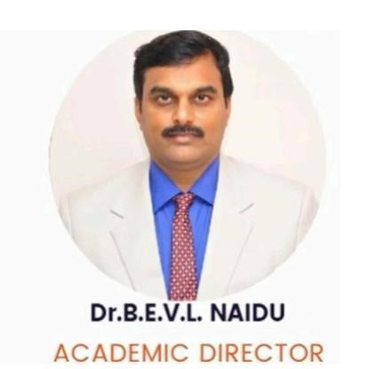

Aditya Degree colleges are the precious gifts presented to the twin Godavari Districts by

ADITYA. Educational group ADITYA Degree College which was established in 1998 in Kakinada fulfilled the hopes and aspirations of many graduates and had been acclaimed as the best degree college under Andhra University. Encouraged by the 100% result in 2003, ADITYA added several feathers to its cap by launching Degree Colleges in Rajahmundry in 2003, in Vizag and Palakol in 2005 and in Tatipaka in 2006.

Needless to say, in the present scenario girls excel more than boys in education and they give tough competition to boys. Owing to their diffidence and inhibition, girls find difficulty in expressing their doubts in a classroom of Co-ed College. Moreover, parents have many objections in sending their daughters to a co-ed college. Realizing this, ADITYA successfully leads Degree colleges for girls to prove their talents in curricular, co-curricular and extra- curricular activiti`es. ADITYA started P.G College also for Women to encourage them for higher education.

### VISION

To provide inclusive education with innovative methods and strenuous efforts for inculcating human values, professionalism and scientific instillation in the realm of Degree Education to all sections of students irrespective of race, region and religion with special focus to stand independently and to emerge as centre for Research and Development.

### MISSION

To provide ample scope for multifaceted development of local youth.

To provide quality higher education to student community.

To Recruit Highly Qualified and Experienced Faculty to provide Quality Education.

### ABOUT ADHOC NETWORK TECH COMPANY - INDIA, CANADA

at Visakhapatnam by an young Women entrepreneur Miss. Devika Pakruthi Founder & CEO with an intention to provide employment opportunities to the youth and also to impart the best quality training and practical exposure to the Students which enhances their employability Skills. Her journey started and collapsed with the wide spread of Covid-19 but her determination and aspirations made her journey more futuristic and she never gave up the thought to GIVE-UP. This is where Devika made her dreams come true and alive. She never expected with a sole objective of making Profit but her determination to impart the quality training made her to reach the peaks of success at the young age.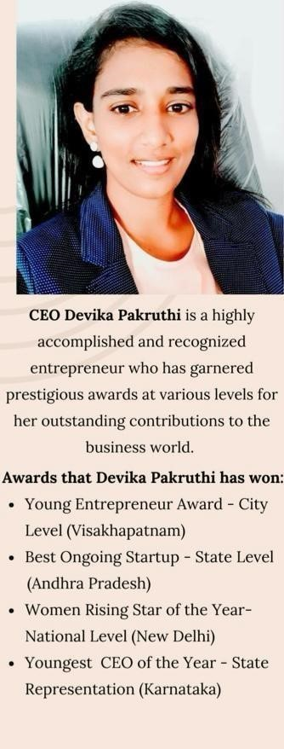

Adhoc Network-we are proud to have been awarded a Hattrick of Awards. This

Achievement is a testament to our commitment to Excellence and

Innovation in the Software development Best heading company in the market. Devika Pakruthi, a name synonymous with innovation, empowerment, and success. As the proud recipient of the

Young Entrepreneur Award, Best Women- Led Startup Award, Women Rising Star of the Year Award and Youngest CEO of the Year Award, Devika Pakruthi has etched her name into the annals of contemporary business history.

***Vision, Mission and values of the Organization:-***

***VISION:-***

Due vision is to be a leading global provider of interactive and reliable Software Solution empowering business to Thrive in the digital age.

***MISSION:****-*

Our mission is to develop cutting-edge Software Solutions that Solve compare business challenges, enhance Operations efficiency and drive Sustainable growth for our client we strive to deliver exceptional value by leveraging emerging technologies, fostering

Strategic partnerships and maintaining a Customer, Centric approach Values

* Innovation
* Excellence
* Collaboration
* Integrity
* Customer Centricity
* Continuous Learning